1. Create two structures for Address and Name.
2. Name ZXXXXADDRESSand ZXXXNAME where XXX is your empcode.

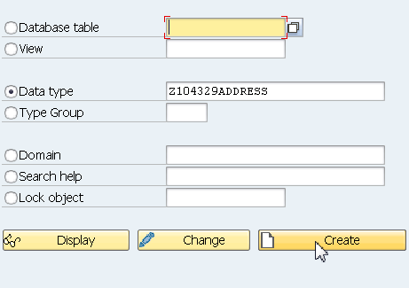

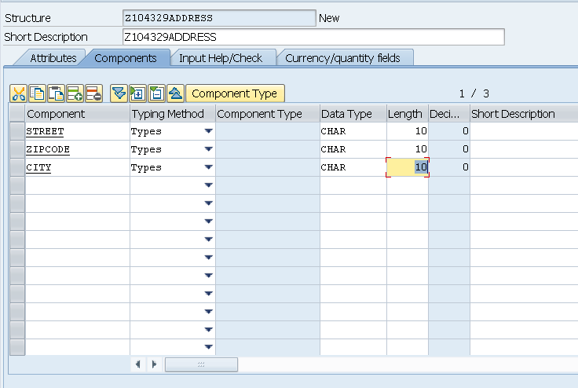

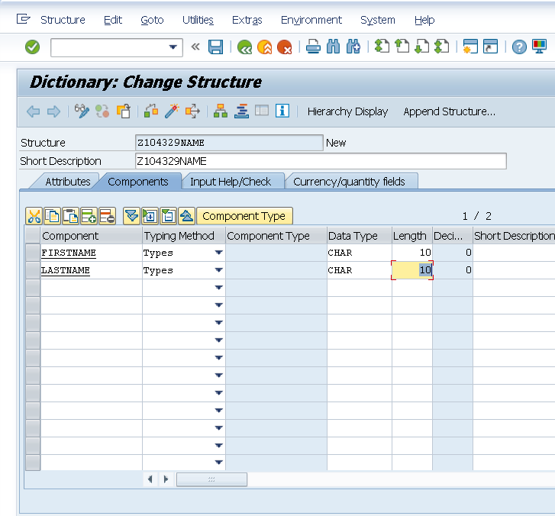

REPORT z.

DATA WA_ADR TYPE Z104329ADDRESS.

DATA WA_NM TYPE Z104329NAME.

WA_ADR-STREET = 'Neurott Str 15 a'.

WA_ADR-ZIPCODE = 'D-69190'.

WA_ADR-CITY = 'Walldrof'.

WA_NM-FIRSTNAME = 'Vandana'.

WA_NM-LASTNAME = 'Koleshwar'.

WRITE WA_ADR-STREET.

WRITE WA_ADR-ZIPCODE.

WRITE WA_ADR-CITY.

WRITE WA_NM-FIRSTNAME.

WRITE WA_NM-LASTNAME.